Word Guessing Game
As we know in these days game are one of the biggest type of entertainment, weather its playing or seeing someone play due to the interaction level between the game and the one playing it or seeing it. User interaction with the system for the required output is always a better way of catching millions eyes. Just like that, This document provides a comprehensive overview and documentation for a C++-based Word Guessing Game. The primary goal of this project is to create an interactive console-based game where users can guess a word selected randomly by the system. Through this system, users can choose difficulty levels, guess letters, and receive feedback on their progress and score.
Source Code
#include <iostream>
#include <ctime>
#include <cstdlib>
#include <cstring>
using namespace std;

class WordBank {
public:
string getRandomWord(int levelChoice) {
string easyWords[35] = {
"dog", "cat", "sun", "pen", "hat",
"book", "star", "moon", "car", "tree",
"bat", "fan", "bag", "map",
"Keys", "fish", "bird", "desk", "lamp", "shoe",
"box", "wall", "door", "pen","best", "game", "play", "code", "test",
"love", "life", "work", "time"
};

string mediumWords[30] = {
"apple", "chair", "banana", "orange", "bottle",
"camera", "garden", "market", "doctor", "family", "friend", "holiday", "vacation", "kitchen", "library",
"planet", "rocket", "school", "cloud", "pencil", "glasses",
"phone", "watch", "table", "window", "guitar", "piano", "computer", "internet", "television"
};

string hardWords[30] = {
"microscope", "electricity", "dictionary", "telescope", "government",
"elephant", "umbrella", "hospital", "mountain", "language",
"programming", "university", "motorcycle", "technology", "calculation",
"microbiology", "anthropology", "sociology", "literature", "engineering",
"psychology", "philosophy", "architecture", "astronomy", "geography", "biology",
"chemistry", "mathematics", "physics", "economics"
};

int index;
if (levelChoice == 1) {
index = rand() % 35;
return easyWords[index];
} else if (levelChoice == 2) {
index = rand() % 30;
return mediumWords[index];
} else if (levelChoice == 3) {
index = rand() % 30;
return hardWords[index];
}
}

static int getMaxAttempts(int levelChoice) {
if (levelChoice == 1) return 10;
else if (levelChoice == 2) return 7;
else if (levelChoice == 3) return 5;
return 0;
}
};

class WordGame : public WordBank {
private:
string wordToGuess;
string guessedWord;
int maxAttempts;
char guessedLetters[26];
int guessedCount;
int score;
// converting uppercase to lower If entered upper , if character is already in lower it wont convert
string toLower(string str) {
for (int i = 0; i < str.length(); i++) {
str[i] = tolower(str[i]);
}
return str;
}

public:
initializing private data members in public function member
WordGame() {
guessedCount = 0;
score=0;
}

void setDifficulty(int levelChoice) {
wordToGuess = getRandomWord(levelChoice);
maxAttempts = getMaxAttempts(levelChoice);
guessedWord = string(wordToGuess.length(), '_');
guessedCount = 0; //reseting guessed leters and score other rounds
score=0;
}

void playGame() {
int attempts = 0;
char guess;

while (attempts < maxAttempts && guessedWord != wordToGuess) {
cout << "\nWord: " << guessedWord << endl;
cout << "Guessed Letters: ";
for (int i = 0; i < guessedCount; i++) {
cout << guessedLetters[i] << " ";
}
cout << "\nGuess a letter: ";
cin >> guess;
guess = tolower(guess);

bool alreadyGuessed = false;
for (int i = 0; i < guessedCount; i++) {
if (guessedLetters[i] == guess) {
alreadyGuessed = true;
break;
}
}
if (alreadyGuessed) {
cout << "You already guessed that letter!" << endl;
continue;
}

guessedLetters[guessedCount++] = guess;

bool correct = false;
for (int i = 0; i < wordToGuess.length(); i++) {
if (wordToGuess[i] == guess && guessedWord[i] != guess) {
guessedWord[i] = guess;
correct = true;
}
}

if (!correct) {
attempts++;
score -= 1;
cout << "Wrong guess! Attempts left: " << (maxAttempts - attempts) << " | Score: " << score;
cout << endl;
} else {
score += 2; // 2 points for guessing correct chracter
cout << "Correct guess! | Score: " << score;
cout << endl;
}
}

if (guessedWord == wordToGuess) {
cout << "\n Congratulations! You guessed the word: " << wordToGuess << endl;
} else {
cout << "\n Game Over! The word was: " << wordToGuess << endl;
}
cout << "Your final score is: " << score << endl;
}
};

int main() { int r=0;
char playAgain;
srand(time(0)); // Seed for random generator
WordGame game;
int choice;
do {
cout<<"\t\t\t-------------------------------" << endl;
cout << "\t\t\t===== WORD GUESSING GAME ===== " << endl;
cout<<"\t\t\t-------------------------------" << endl;
do{
cout << "Choose difficulty level:" << endl;
cout << "1. Easy" << endl;
cout << "2. Medium" << endl;
cout << "3. Hard" << endl;
cout << "Enter your choice: ";
cin >> choice;
cout<<endl;

if (choice<1 || choice>3) {
cout << "Invalid choice! Again choose the difficulty level (1-3): ";
cin >> choice;
}

system("cls");
cout<<"\n\t\t\t STORM YOUR BRAIN AND WIN THE SCORE"<<endl<<endl;
}
while (choice<1 || choice>3);

game.setDifficulty(choice);
game.playGame();
cout<<" \n Do you want to play again (Y/N): ";
cin >> playAgain;
system("cls");
cout << endl;
r++;
} while (playAgain == 'Y' || playAgain == 'y');
cout<<"\n ROUNDS PLAYED BY THE USER :"<<r<<endl<<endl;

cout << " \n \t\t\tThank you for playing!" << endl;
system("pause");
}

Explanation
WordBank Class
The WordBank class is responsible for managing the words used in the game and determining the maximum number of attempts for each difficulty level.
- getRandomWord(int levelChoice): This function takes an integer levelChoice (1 for Easy, 2 for Medium, 3 for Hard) as input. It contains three arrays of strings: easyWords, mediumWords, and hardWords, each storing a collection of words corresponding to the respective difficulty. Based on the levelChoice, it randomly selects and returns a word from the appropriate array.
- getMaxAttempts(int levelChoice): This static function returns the maximum number of attempts allowed for a given levelChoice. Easy level gets 10 attempts, Medium gets 7, and Hard gets 5.
WordGame Class
The WordGame class inherits from WordBank and encapsulates the core game logic, including managing the word to be guessed, the player's progress, and their score.
- Private Members:
  - wordToGuess: Stores the randomly selected word that the player needs to guess.
  - guessedWord: Represents the player's current progress, initially filled with underscores and gradually revealing correct letters.
  - maxAttempts: Stores the maximum number of incorrect guesses allowed for the current game.
  - guessedLetters[26]: An array to keep track of all letters the player has already guessed.
  - guessedCount: The current count of letters in guessedLetters.
  - score: The player's current score in the game.
  - toLower(string str): A helper function to convert a given string to lowercase. This ensures that letter comparisons are case-insensitive.
- Public Members:
  - WordGame() (Constructor): Initializes guessedCount and score to 0 when a WordGame object is created.
  - setDifficulty(int levelChoice): This function sets up a new game based on the chosen difficulty. It calls getRandomWord() from the WordBank base class to get a word, sets maxAttempts using getMaxAttempts(), initializes guessedWord with underscores, and resets guessedCount and score for a new round.
  - playGame(): This is the main game loop.
    - It continuously displays the guessedWord and the letters already guessedLetters.
    - It prompts the user to guess a letter.
    - It checks if the guessed letter has alreadyGuessed. If so, it informs the user and continues to the next iteration.
    - The guessed letter is added to guessedLetters.
    - It iterates through wordToGuess to check if the guessed letter is present. If a correct letter is found and not already revealed in guessedWord, it updates guessedWord.
    - If the guess is !correct, attempts are incremented, and score is decremented by 1.
    - If the guess is correct, score is incremented by 2.
    - The loop continues until attempts reach maxAttempts or guessedWord matches wordToGuess.
    - Finally, it announces whether the player won or lost and displays the final score.
Main() Function
The main function is the entry point of the program and orchestrates the overall game flow.
- Random Seed: srand(time(0)) initializes the random number generator using the current time, ensuring different words are chosen each time the program runs.
- Game Loop: A do-while loop allows the user to play multiple rounds.
  - It displays a welcome message and prompts the user to Choose difficulty level (1 for Easy, 2 for Medium, 3 for Hard).
  - It includes input validation to ensure the choice is within the valid range (1-3).
  - system("cls") clears the console screen.
  - It calls game.setDifficulty(choice) to initialize the game and game.playGame() to start the game.
  - After each game, it asks the user if they want to play again (Y/N).
  - It keeps track of the number of rounds played by the user.
- Program Exit: Once the user decides not to play again, it displays the total rounds played and a "Thank you for playing!" message before exiting.
- system("pause") is used to keep the console window open until the user presses a key, allowing them to view the final output.

Sample Output Screenshots
Initial Program Startup
This screenshot displays the initial welcome message from the Word Guessing Game, indicating the start of the program execution and prompting the user to choose a difficulty level.
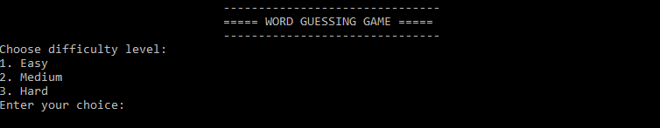
Choosing Difficulty Level and Game Start
This screenshot shows the user selecting a difficulty level (e.g., "1" for Easy) and the subsequent clear screen, followed by the "STORM YOUR BRAIN AND WIN THE SCORE" message, indicating the game has started with the chosen difficulty.
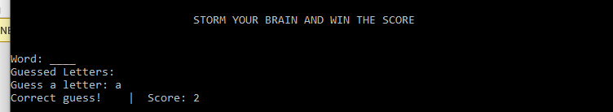
In-Game Play (Correct and incorrect Guess)
This screenshot captures a moment during gameplay where the user makes a correct guess. It displays the current state of the guessedWord, previously guessedLetters, the user's correct guess and incorrect guess and the updated score.
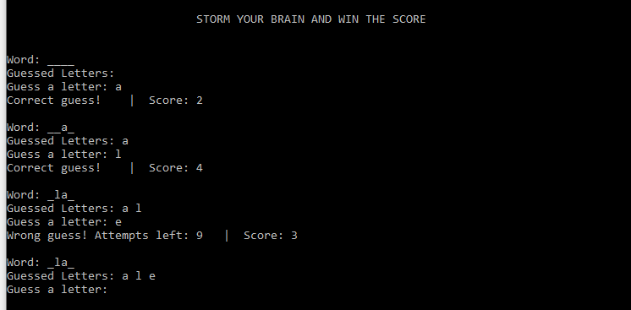
Handling Already Guessed Letters
This screenshot illustrates the system's response when a user attempts to guess a letter that has already been guessed. The "You already guessed that letter!" message should be visible.
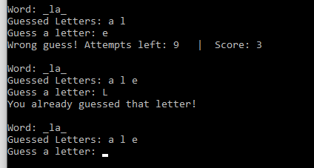
Game End (Win Scenario)
This screenshot displays the message shown when the user successfully guesses the word before running out of attempts. It should include the congratulatory message, the revealed word, and the final score.
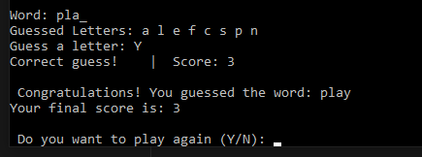
Clearing screen for next round:
Here after winning the game it asks for weather user wants to play another game or round if it says y then it clears the screen and starts the game again, with same logic as pr.vious just clearing the score for next round.
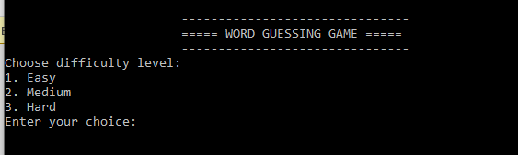
Game End (Lose Scenario)
This screenshot captures the message displayed when the user runs out of attempts without guessing the word. It should show the "Game Over!" message, the correct word, and the final score and again asking weather the user wants to continue further and clears the screen and reset the score.
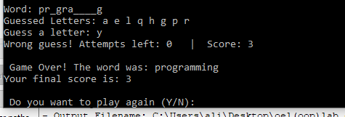
Clearing screen for next round:
Here after losing the game it asks for weather user wants to play another game or round if it says y then it clears the screen and starts the game again, with same logic as previous just clearing the score for next round.

Play Again Prompt and Program Exit
This screenshot shows the prompt asking the user if they want to play again. If the user chooses 'N' or 'n', it should display the total number of rounds played and the "Thank you for playing!" message before the program terminates.
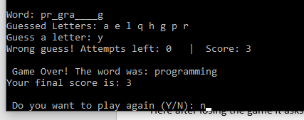
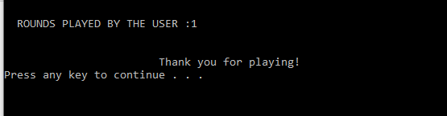

Here it would wait for the ser to press any key and then exit. In real life game senerio its important that user gets to see his or her final scoring before program ends.
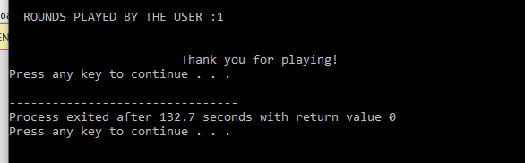

And then programs terminates.

